COMMON ANODE TYPE PN PHOTO DIODE.
APPLICATION FOR LD LOCALIZER
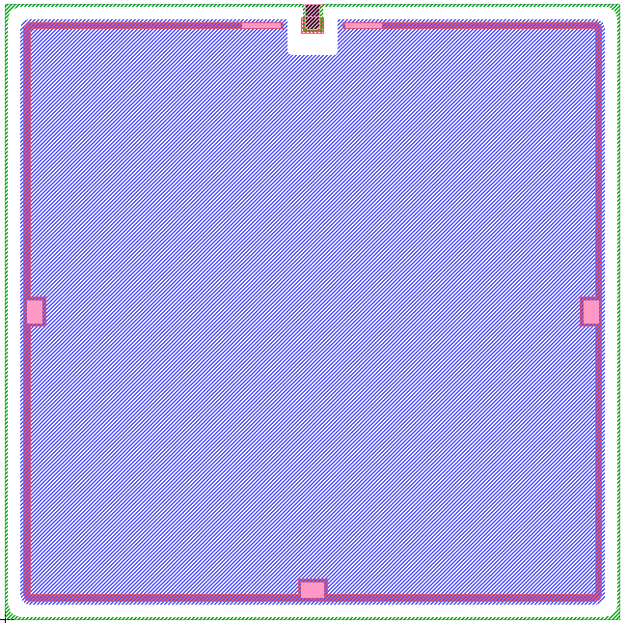
●DIE SIZE 4.3× 4.3 mm2
●DIE THICKNESS400 300 ± 20um
●METALLIZATION
TOP Al
BOTTOM Ag

●PASSIVATION Silicon Oxide
●BONDING PAD SIZE
CATHODE（TOP） 150um×200um
ANODE (BOTTOM)

●ACTIVE AREA 4.02× 4.02 mm2

●ABSOLUTE MAXIMUM RATINGS ( Ta = 25℃ )
Parameter | Symbol | Maximun rating | Unit
Reverse Breakdown Voltage | BVR | 30 | V
Junction Temperature | TJ | 150 | ℃

●ELECTRICAL / OPTICAL CHARACTERISTICS ( Ta = 25℃ )
Parameter | Symbol | Condition | Min | Typ | Max | Unit
Forward Voltage | V_{F} | I_{F}=10mA， | 0.5 | 0.8 | 1.5 | V
Reverse Breakdown Voltage | BV_{R} | I_{R}=10uA | 30 |  |  | V
Dark Current | I_{D} | V_{R}=10V |  |  | 10 | nA
Spectrum Sensitivity | λ |  | 430～1100 |  |  | nm
Peak Sensing Wavelength | λ_{P} |  |  | 880 |  | nm
Note(1):Parallel light of 1,000Lux illumination is applied by a Tungsten lamp of 2856k.

4300

4300

地址： 深圳市宝安44创业一路富源商贸中心B703 邮编：518010
电话：0755-29129090

